Bareroot Division Manager 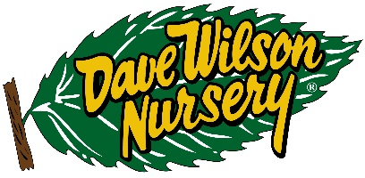

**Primary Responsibilities:**

* Oversee daily operation of production and growing of the bareroot tree program, including but not limited to planting, irrigation, fertilization and chemical applications, plant care and growing functions, harvesting, order processing
* Responsible to oversee and assess labor needs and efficient use of workforce
* Maintain working knowledge of changes and advancements in growing technology
* Adherence to SOP’s
* Assist in preparation and adherence to budgetary guidelines
* Maintain oversight of properly maintained equipment
* Seek/ promote educational opportunities for personal development as well as staff

**Qualifications/Skill Requirements**

* 5-10 years experience growing bareroot trees preferred
* Strong organizational skills
* California drivers license
* Strong written and verbal skills
* Basic proficiency with computer programs usage such as spreadsheets and reports
* Bilingual (English/Spanish)

**Working Conditions**

* Job function is typically performed in an outdoor environment in seasonal weather conditions; occasional work in an office environment. Some light travel is required.

**Physical Requirements:**

* Sit and/or stand for long periods of time
* Drive vehicle for several hours at a time
* Lift 40 lbs.
* Frequently walk on unimproved surfaces

Please send resumes to [jhuiltron@davewilson.com](mailto:jhuiltron@davewilson.com).