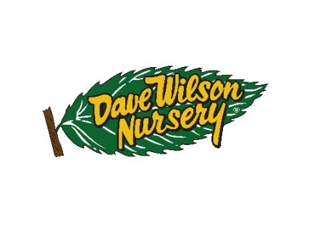
Since 1938, Dave Wilson Nursery has been the leading provider of bareroot and potted fruit, nut and shade trees in the United States. Together, with Zaiger Genetics, they have brought to market the first self-fertile almond, Independence and other fascinating fruit, like the Pluot. The Dave Wilson Nursery home ranch is settled along the Tuolumne River in the heart of the Central Valley of California. In addition to the home ranch, you can find more trees grown at our Red Rock Ranch in Hickman, our research facility in Reedley and our most recent expansion (2020) of 24 additional acres of greenhouse growing space in Ripon, California.

Dave Wilson Nursery is hiring for the role of: Mechanic- Field Division

Job Summary
Mechanics maintain, repair, and overhaul machinery, equipment, and vehicles on nursery property or in the nursery equipment repair shop. Mechanic’s duties include repairing and adjusting malfunctioning diesel and gas-powered tractors; traveling to company locations to make emergency repairs; making minor adjustments; performing preventive maintenance by periodically testing and cleaning parts; and tuning and overhauling engines.

When a piece of equipment is not working correctly, mechanics must figure out what is wrong. They use testing equipment to find out where the engine the problem is, watch the engine while it is running to find any loose parts or leaks, and sometimes take the entire engine apart to find a problem. When the problem is found, equipment mechanics replace the worn and broken parts. They monitor the repaired machine to make sure it is running properly again. If the equipment, such as a tractor, was in an accident, repairers may repair bent or torn sheet metal.

Primary Responsibilities (productivity measures)
- Adjust and clean engine parts.
- Tune machine engines: know plug calibration, engine timing, wire firing order, carburetor adjustment, and point calibration
- Examine equipment to locate loose or worn parts.
- General welding knowledge
- Use testing equipment to locate problems inside engines.
- Replace worn or broken parts.
- Test repaired equipment to ensure the machine is running properly.
- Write service reports to list maintenance or repairs.
- Repair dented and torn sheet metal on the outside of equipment.
- Perform oil changes and lubrication: Drain and refill oil and filter; set jack and jack stands; grease chassis and remove excess grease; clean and sweep after the job is finished
- Perform safety inspections: inspect equipment for cracks and wear; adjust brakes, replace brakes, adjusts bearings, inspect air hoses and replace as needed
- Adhere to safety standards and rules: wear safety goggles when needed, ask for help when there is heavy lifting, check for hazardous areas and hazardous surrounding objects

Additional Responsibilities:

Demonstrate the ability to work with a low level of social interactions and to work independently.

Communicate effectively with equipment operators in order to find out what is wrong with the machinery.

Demonstrate good internal customer service; ability to serve the company across departments and satisfy equipment needs of other departments

Read and understand work-related materials.

Good writing skills

Must fully complete and be very exact in performance of the work. This ensures that equipment operates efficiently and safely.
Qualifications/Skill Requirements:

California drivers license
High school diploma, GED, or equivalent
Technical training course of 18 months to two years; or on-the-job equivalent

Working Conditions:
- May work indoors or outdoors, depending on the machinery.
- Are sometimes exposed to hazardous situations that produce minor cuts, burns, and bruises
- Wear protective or safety attire, such as gloves or glasses.
Physical Requirements:

- Use hands to handle, control, or feel objects, tools, or controls.
- Stand for long periods of time.
- Bend or twist the body.
- Kneel, stoop, crouch, or crawl.
- Hear sounds and recognize the difference between them.
- See details of objects that are less than a few feet away.
- Use muscles to lift, push, pull, or carry heavy objects.
- Make fast, simple, repeated movements of fingers, hands, and wrists.
- Have the ability to move hands skillfully and easily in placing and turning motions
Please send resumes to jhuiltron@davewilson.com to schedule an interview.

